Bivariate event scale relationships between urine volume and urine N load for FRNL Plantain trials (14-18 November 2016 and 1-5 May 2017)
Shorten & Welten

The bivariate event scale relationship between urine volume (V; litres) and urine N load (L; grams) can be appropriately described by a multivariate lognormal distribution (based on a total of 1154 measured urination events from both trials).

The probability density function (pdf) of the d-dimensional multivariate normal distribution is given by
$f\left(x|μ,Σ\right)=\frac{1}{\sqrt{|Σ|({2π)}^{d}}}exp⁡(-\frac{1}{2}(x-μ)Σ^{-1}{(x-μ)}^{T})$; (1)

where x and μ are 1-by-d vectors (μ is the mean) and $Σ$ is a d-by-d symmetric positive definite covariance matrix ($\left|Σ\right|$ denotes the matrix determinant).

The multivariate lognormal distribution for volume (V) and load (L) is described by Eq. 1 (d=2) with

$x=\left[\begin{matrix}\log_{10}(V) \\ \log_{10}(L)\end{matrix}\right]$ (2).

Random samples from the lognormal distribution are obtained by first obtaining a random sample $(x_{i})$ from the multivariate normal distribution $x_{i}\sim f\left(x|μ,Σ\right)$ and then

$\left[\begin{matrix}V_{i} \\ L_{i}\end{matrix}\right]=\log_{10}(x_{i})$. (3)

Results:
2016:
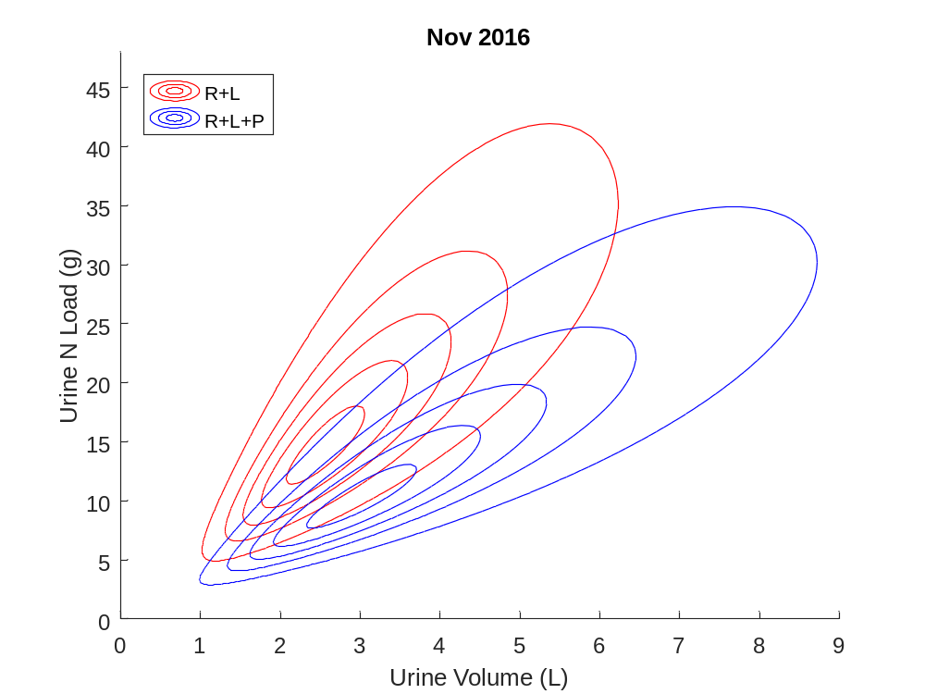
R+L (R²=0.70):
$μ$ =
0.400851532821705
1.156701815797196
$Σ$ =
0.033598852595467 0.033361752139528
0.033361752139528 0.047123025480434

R+L+P (R²=0.78) Plantain treatment:
$μ$ =
0.467568661873128
1.001458931478406
$Σ$ =
0.048567907998531 0.049173046925188
0.049173046925188 0.063645720330866

2017:

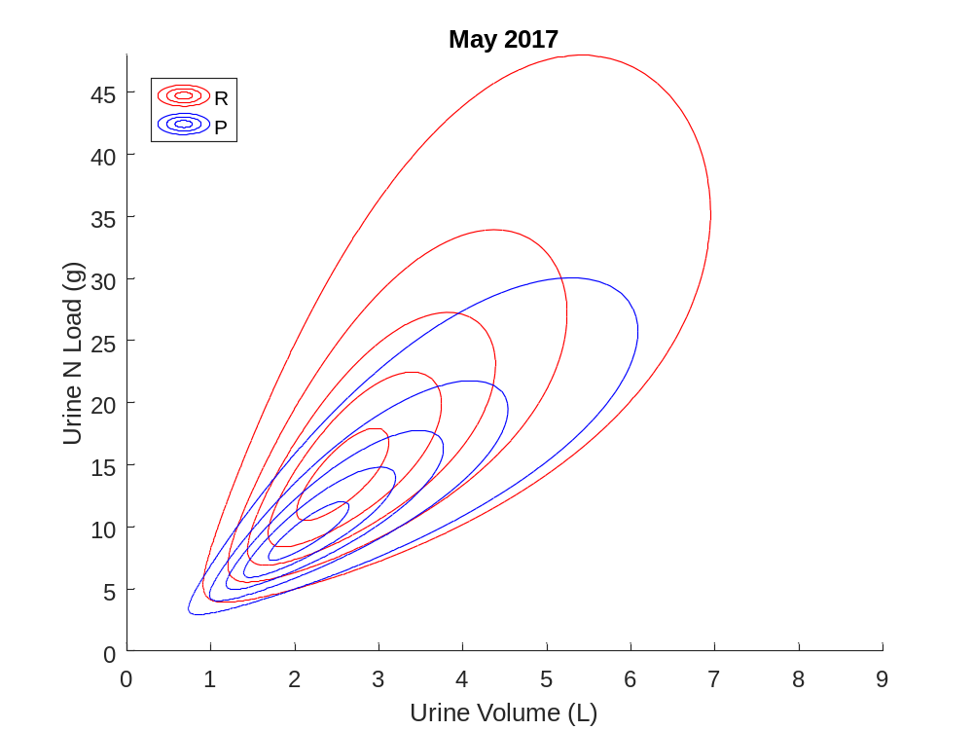
R (R²=0.57):
$μ$ =
0.399268390330878
1.137409186102879
$Σ$ =
0.042503648641255 0.039424452896646
0.039424452896646 0.064162520068606

P (R²=0.75) Plantain treatment:
$μ$ =
0.323846166625746
0.971917184238190
$Σ$ =
0.045976213128617 0.043850511669727
0.043850511669727 0.055567869824169

